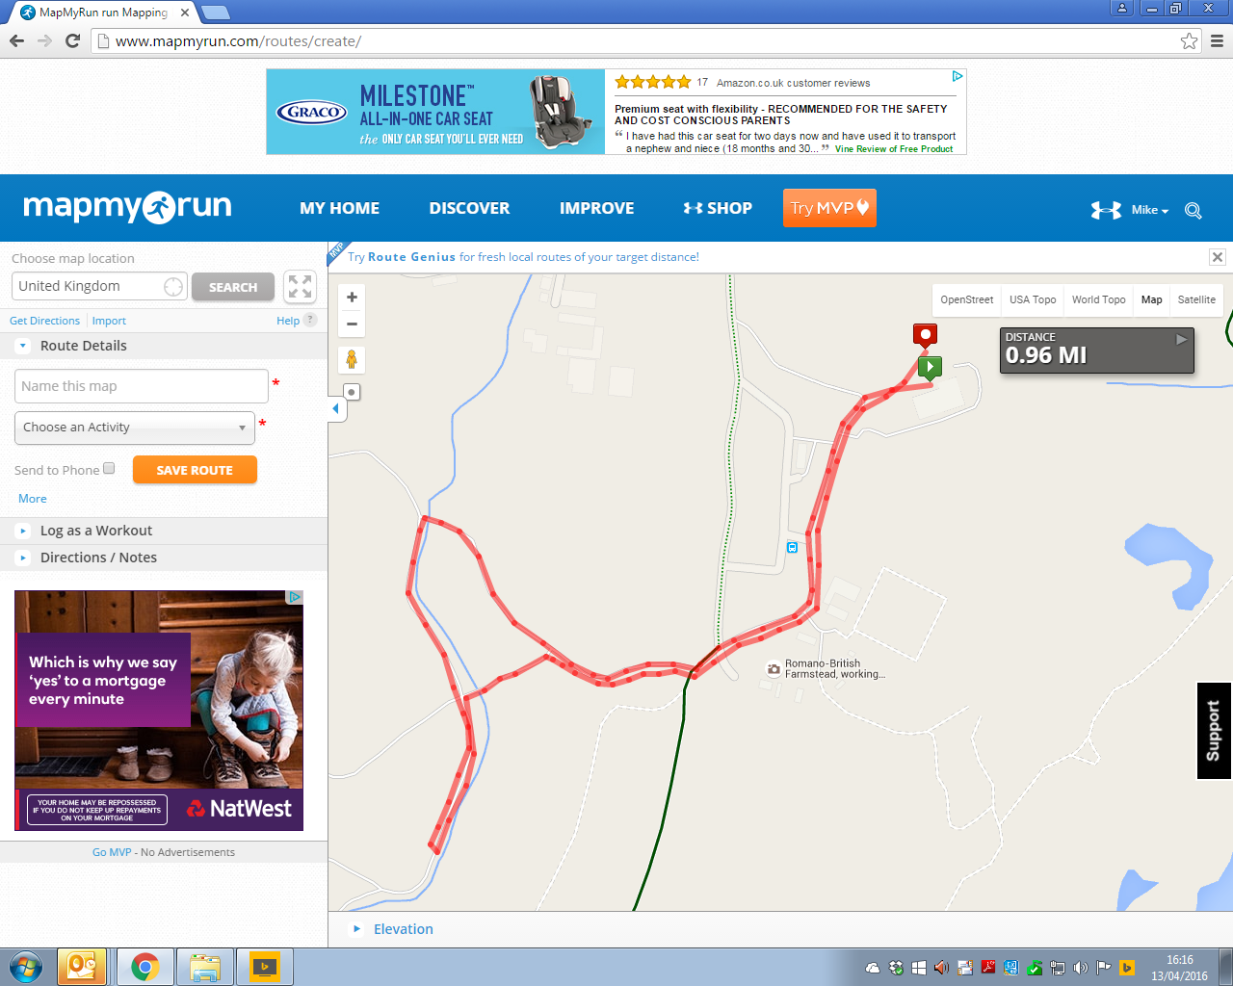

**UPTON JUNIOR SUMMER SERIES ROUTE MILE**

**Route Instructions**

**Start in front of the house. Runners to go through 1,2,3,4 left to 6 right to 7, go round a bollard then return back through 6,5,4,3, 2, 1 and finish in front of house.**

**Start/finish in front of house**

**7**

**6**

**5**

**4**

**3**

**2**

**1**